Genesys Electronics Design

Python Software Guidelines

Document Number: GD-0008-GUIDE22
Revision: WIP
Date: 11-Jun-21

Document Control Sheet

Document Title: | GD-0008-GUIDE22 Genesys Python Software Guidelines
Document Number: | GD-0008-GUIDE22
Author: | Michael C, Michael Z
Date: | 11-Jun-21
Revision: | WIP
Change Authority:

*Revised By:
Name:
Date:
Signed:

Reviewed By:
Name:
Date:
Signed:

Reviewed By:
Name:
Date:
Signed:

*Approved By (Change Authority):
Name: | G Sizer
Date:
Signed:

* These sections must be completed for formal release.

Amendment Record
Revision | Description of Changes | Date | Revised | Approved
WIP | Initial Draft | 11-Jun-21 | MC, MZ

Contents
Document Control Sheet 2
Amendment Record 3
Contents 4
1 Introduction 5
2 Development Tools 6
2.1 Linting 6
2.2 Packaging 6
3 Development Environment 7
3.1 Python venv 7
3.2 Setting up a New Python Project Venv 8
4 Design Coding Standards 9
5 Software Development Process 10
6 Software Verification Process 11
7 Other Design Principles 12
Annex A Naming conventions 14
Annex B py File Structure 15
Annex C Software Development Activity Sequence Checklist 16
Annex D App-Modules Cross Platform Status 17

Introduction
1.1

Development Environment
  - Python venv

When working on multiple projects, on multiple PCs, or with multiple collaborators, Python projects quickly become prone to errors due to differences in package versions or Python interpreter versions. The source of these errors can be difficult to find and can be exacerbated when the errors manifest during run-time of a python executable.

To prevent such potential issues and maintain a clean development environment, all Genesys Python projects should make use of a Python Virtual Environment to maintain Python interpreter versions and package versions across multiple PCs and collaborators. The only exceptions to this are any small python tools developed for very limited usage or personal usage.

The “venv” python module provides support for creating lightweight “virtual environments” that live within your python project. You can choose a specific Python interpreter version and install packages to the venv which is just a self-contained directory tree within your python project.

Note that information in the following subsections relate to operating venv on Windows, for venv instructions on Unix/MacOS platforms see:
https://packaging.python.org/en/latest/guides/installing-using-pip-and-virtual-environments/#creating-a-virtual-environment

Venv Commands Summary Table
Operation | Command | Description
Create Venv | py -3.4 -m venv env | Create a python virtual environment named “env” using a specific version of python (V3.4 in example).
Activate Venv | env\Scripts\activate | Activate the venv to enable installation of packages, etc, within the venv.
Upgrade Pip | python -m pip install  --upgrade pip | Upgrade pip to latest version. This should be done for a new venv.
Generate Requirements.txt | pip freeze > requirements.txt | Generate requirements.txt to ensure other PCs can sync their Python packages for the project.
Install Requirements.txt | pip install -r requirements.txt | Install requirements.txt Python packages from your project into your venv on a particular PC.
Deactivate Venv | deactivate | Deactivate a venv. Closing cmd terminal will also deactivate the venv.
Table 3.1.1 – Summary of useful venv commands.

  - Setting up Venv

Download and install the Python interpreter version you wish to use in any location on your PC. Note that venv will only work for Python 3 and above. For python 2 virtual environments please use the package “virtualenv”. However, this guide will only cover instructions relating to venv.

In File Explorer open your project folder that will contain your python scripts and type cmd into the address bar and press enter. A Command Prompt terminal will open at the current path location.

To create a new virtual environment there are 3 main methods listed below.

The first method will generate a new virtual environment named “env” using your system’s most current primary version of python interpreter, but this will contain none of your currently installed packages.

py -m venv env

The second method will generate a new virtual environment named “env” using your system’s current primary version of python interpreter, but it will also include all of your currently installed packages.

py -m venv env –-system-site-packages

The third method will generate a new virtual environment named “env” using a specific version of python already installed anywhere on your PC. This should be used when working on an existing project from a different PC.

py -3.4 -m venv env

Note that “env” is common naming convention for the virtual environment but you may name it something specific to your application.

You can check the project folder to confirm whether the “env” folder was generated.

To activate the new virtual environment type the following:

env\Scripts\activate

This will temporarily cause the virtual environment to be the primary python interpreter used by your system. You should see “(env)” at the start of your command line to indicate this change. You can also check this by typing “where python” to see a list of installed python interpreters on your PC. The active python interpreter should be at the top of the list as seen in figure 3.2.1 below.

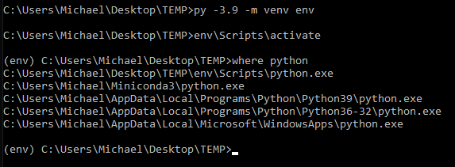
Figure 3.2.1 – Example screen capture of venv creation, activation, and confirming activation.

Once the new venv is active, the first thing to address is updating Python’s package installer “pip”. Depending on the version of python you chose to create your venv with, the version of pip in that environment will be whatever was originally bundled with that particular release of python. To update pip inside your venv use the following command (whilst venv is active):

py -m pip install -–upgrade pip

Whilst venv is active you can install packages into your venv as you would normally using the pip install command. BE CAREFUL when installing specific package versions that pip does not automatically install supporting packages. For example when installing matplotlib==2.0.0, pip will automatically install all supporting packages but at their latest release version. This will break older versions of matplotlib. This issue does not occur when using requirements.txt for package installation as described below in paragraph 2.2.9.

Once you are done with installing the packages that you need for your project, you should generate a “requirements.txt” file to allow easy syncing of python packages on other PCs. You can do this via the following command:

pip freeze > requirements.txt

If you are setting up venv on a new PC for a project that already has the requirements.txt generated, whilst your venv is active you can install all of your project’s packages using the command below:

pip install -r requirements.txt

To deactivate the venv simply type deactivate to return to your global python interpreter in cmd. Quiting out of the cmd terminal will also deactivate the venv for the next time cmd is opened.

Deactivate

  - Working with Venv

To begin working on your python project in VScode using a venv, open your project folder in VScode. VScode should automatically find your venv python interpreter and you can select the venv as you would any other interpreter. In the bottom right of the VScode window select “Python” as the language and click on the version number. This should open a dropdown that lists Python interpreters that VScode finds on your system. Simply select your venv and this will activate it within VScode. Running your scripts from VScode will now use your venv and its packages.

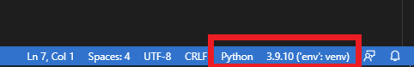
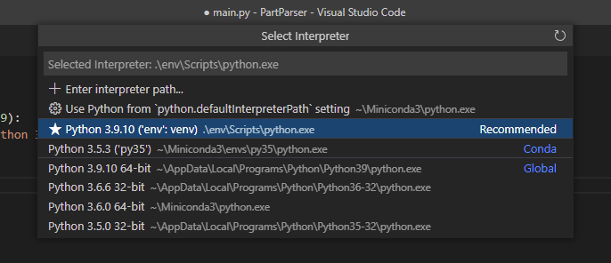
Figure 3.3.1 – Activate venv in VScode via version selection on bottom right of the VScode window. Select the venv in the subsequent dropdown.

VScode may give errors when attempting to activate the venv. The most likely reason for this will be that powershell will restrict the running of scripts by default. To fix this within vscode, press ctrl + p and type “settings.json”. Add the following lines of code to the end of your settings.json file:
"terminal.integrated.profiles.windows": {
"PowerShell": {
"source": "PowerShell",
"icon": "terminal-powershell",
"args": ["-ExecutionPolicy", "Bypass"]
}
},
"terminal.integrated.defaultProfile.windows": "PowerShell"

To ensure collaborators are using the correct version of python during development you can run a check from within your code to force an error if the script is not being run with the correct version of python. Copy the code below and paste it into the start of your “main.py” script. Note the example code below is checking for Python 3.4 but you should change this to suit your version.

Import sys
if sys.version_info[0:2]!=(3,4):
raise Exception(“requires Python 3.4”)

Development Tools
  - Linting

Linting shall be done using pylint.

The Genesys pylintrc file that contains linting rules to match the Genesys standard shall be used.

To supress pylint warnings, add “disable=XXX, XXX” to suppress warnings (where XXX represents an warning code. This is not recommended unless absolutely necessary and reasoning should be commented.

To run pylint: python -m pylint application.py

Tip: Setup pylint in Visual Studio Code for realtime linting

  - Building Executables

Packaging shall be done using pyinstaller

The Genesys template .spec file shall be used and modified for the project.

In the .spec file, the following fields should be updated:
- Update the “datas” array to include folders where assets such as images and template text files are located.
- To disable the console window when running the executable. Set “console=False”
- To add the executable icon, set the icon parameter in exe=EXE(…) (eg. icon=”assets\\genesys.ico”
- To set the built executable name, set name=”XXXX”.

To package the executable, run “pyinstaller application.spec”. If you are using a virtual environment, ensure it is activated before packaging the executable.

Note: all libraries and dependencies (including labjack where required) shall be installed on the host before packaging. In the case where Labjack is used, it must also be isntalled on the deployed system.

Any configurable file, or files that are used by an subprocess must be copied to the dist folder to be located in the directory of the executable.

Design Coding Standards

Follow standard “pythonic” coding practices.

Where possible use native python packages that ship with python. Otherwise, if for some reason there are benefits to making a custom module then this is allowed. But it should be avoided for the sake of keeping Genesys python scripts as uniform as possible. Developers should be able to transition between python projects with ease and see that most of the same packages are used. The standard packages to be used are listed in section 4.1.

4.1 Standard Packages
4.1.1 Logging
Use logging package.
4.1.2 Time
Use time package.
4.1.3 Threading
Use threading package.
4.1.4 Multiprocessing
Use multiprocessing package.
4.1.5 Queues
Use queue package.
4.1.6

4.1 Coding Style
Use autopep8 extension in VScode. Change settings “format on save”.
Python is often used as a quick tool to automate a task and so can end up looking quite messy if a small Python script is written in a hurry. As a general rule of thumb, this is OK for personal use such as automating your personal day-to-day tasks or a one-off operation. However, if there is any potential for:
- other people to use the script,
- copying part of the script for use in other projects,
then the coding styles discussed in this guide must be used.
For style guidance see PEP8 documentation.
For docstring style, google style docstrings are to be used for all projects and internal modules.

Software Development Process
TODO

Software Verification Process
TODO

Other Design Principles
TODO

- Naming conventions

Follow the PEP8 standard
- py File Structure

All .py files shall follow a code division template.

- Main function should be called main()
- End main file with the following to the program can identify the functions available below the main function before executing:
  - 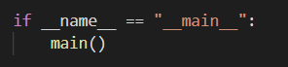

- Software Development Activity Sequence Checklist

TODO

- App-Modules Cross Platform Status
Table E.1 Module status descriptions

Status Levels | Description
Vapourware | The module has not been started
Basic functionality | The module has some basic functionality but not yet fully functional
Critical mass | The module is fit for purpose but needs additional features added to meet all module requirements
Maintenance | The module is fully functional and meets all module requirements

Table E.2 Module cross platform summary
 | Module Description | Status
 | Generic

